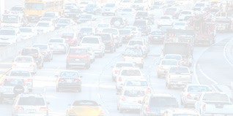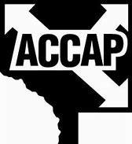

Need assistance with car repairs, insurance or
vehicle registration and don’t know where to turn?

- Up to $2000 in grants may be available, if eligible
- Grants do not need to be paid back
- No car repair estimate needed
Transportation Solutions
A partnership between Anoka County & Anoka County Community Action Program

Program Requirements:
- Anoka County Resident
- Meet low income guidelines
- Meet program eligibility guidelines
- Impacted by Covid-19
- Valid MN Driver’s License

- Vehicle in applicant’s name
- Proof of insurance (for repairs)
- Costs don’t exceed car’s value
- Grants must be pre-approved
- One-time assistance
- Dependent on funding

Applications available at: | Need more information?
Blaine Human Service Center 1201 89th Ave NE, Suite 235  Blaine, MN 55434 or  www.anokacounty.us/jtc | Contact Irina Astashinsky Transportation Coordinator 763-324-2318  Irina.Astashinsky@co.anoka.mn.us
Anoka County is an Equal opportunity employer/service provider.
For accessible formats of this publication, call 763-324-2300, or your preferred relay service.

